What on Earth is “The Chilean Blob”?



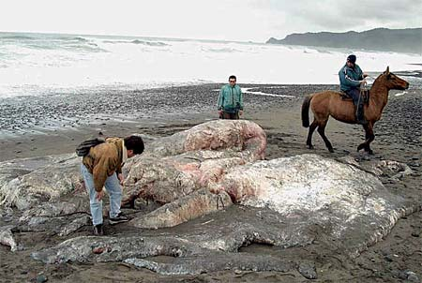

Nucleotide sequence of DNA isolated from Chilean Blob.
TAATACTAACTATATCCCTACTCTCCATTCTCATCGGGGGTTGAGGAGGACTAAACCAGACTCAACTCCG
AAAAATTATAGCTTACTCATCAATCGCCCACATAGGATGAATAACCACAATCCTACCCTACAATACAACC
ATAACCCTACTAAACCTACTAATCTATGTCACAATAACCTTCACCATATTCATACTATTTATCCAAAACT
CAACCACAACCACACTATCTCTGTCCCAGACATGAAACAAAACACCCATTACCACAACCCTTACCATACT
TACCCTACTTTCCATAGGGGGCCTCCCACCACTCTCGGGCTTTATCCCCAAATGAATAATTATTCAAGAA
CTAACAAAAAACGAAACCCTCATCATACCAACCTTCATAGCCACCACAGCATTACTCAACCTCTACTTCT
ATATACGCCTCACCTACTCAACAGCACTAACCCTATTCCCCTCCACAAATAACATAAAAATAAAATGACA
ATTCTACCCCACAAAACGAATAACCCTCCTGCCAACAGCAATTGTAATATCAACAATACTCCTACCCCTT
ACACCAATACTCTCCACCCTATTATAG

Directions for the Identification of the Chilean Blob

  - The nucleotide sequence, in FASTA, of a segment of the blob’s DNA is on the previous page.
  - On the internet, go to the NCBI website (http://www.ncbi.nlm.nih.gov/).
  - Choose BLAST from the menu on the right.
  - Select nucleotide BLAST from the menu, under Basic BLAST.
  - In the box under “Enter Query Sequence” insert the blob’s DNA sequence.
  - Near the bottom of the page, under ”Choose Search Set” and under ”Database”, click on “Others”.
  - Click on the” BLAST” button at the bottom of the page.
  - Wait for your results.
  - When BLAST is done with its search, you can scroll down and see a colorized diagram indicating the degree of similarity of the BLAST hits to blob’s DNA sequence. Red and pink/purple mean a good match, while green, blue and black indicate a poor match. If the colored line spans the entire length of the window, then the “hit” sequence matches the query sequence along its entire length. Since, the first match will be that of the blob’s won species, we expect to see a high quality match along the entire length of the query sequence.
  - Below the colorized diagram is a “hit list” of your results. The first “hit” will identify the blob, since it represents the closest match to the query sequence.

